Title: Times New Roman 14 Bold (Capitalise Each Word)

First Author (Presenting author)¹, Second Author¹…, Corresponding Author²* (Author names are in the format of Given name followed by Surname)

¹Author 1 affiliation
²Author 2 affiliation
……..
Email address: xxxx@xxx.xx (Email address of the presenting author, and the corresponding author)

Abstract
The whole document has to be typed in ‘Times New Roman’ with 1.5 line spacing: the title in 14 pt bold Capitalise Each Word, the author names in 12 pt letters, the affiliation addresses in 11 pt letters and the abstract text in 12 pt letters. The title, the author names, the affiliation addresses and the abstract text should be separated with a blank line. The word limit for the abstract is 300 words, and may include figures.
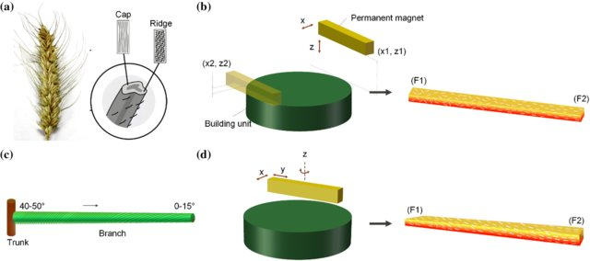
Figure 1. Bioinspired architecture for soft actuator design [1]
Keywords: 3-6 keywords, separated by commas

References:
If references are needed, put reference numbers into square brackets [1].
[1] Ren L Q, Li B Q, Song Z Y, Liu Q P, Ren L, Zhou X L. 3D printing of structural gradient soft actuators by variation of bioinspired architectures, Journal of Materials Science, 2019, 54(8): 6542-6551.

Please DELETE the words in red before you submit your Abstract.

